
COMPUTER NETWORKS CYS2003
ASSIGNMENT 01
MUHAMMAD ALI KHAN
CYS232035
Socket Programming
Remote System Monitor – Lab Setup & Configuration Documentation
1. Introduction
This project implements a Remote System Monitoring Tool using Python TCP sockets.
The system consists of:
- Server (Monitoring Agent) running on Kali Linux VM
- Client (GUI Dashboard) running on Windows Host
The client connects to the server over a network and retrieves CPU, RAM, and Disk usage information.
This setup replicates a simplified enterprise monitoring environment, where a SOC (Security Operations Centre) dashboard retrieves system telemetry from remote endpoints.
1.2 Objectives
- Implement TCP socket programming
- Create a real time monitoring system
- Design a client GUI
- Send system statistics across a network
- Implement alerts using color coded thresholds

2. Lab Architecture Overview
Environment Used
Component | Machine | Role
Kali Linux VM | Virtual Machine | Acts as Server, collecting local system metrics
Windows Host PC | Physical Machine | Acts as Client, displaying a GUI dashboard
Why Kali Linux as the Server?
Kali is commonly used in cybersecurity labs because:
- It provides a controlled, isolated environment
- It behaves like a real Linux endpoint
- It allows easy testing of network connections, firewalls, and monitoring agents
- It is safe for running server side scripts without affecting the host OS
Why Windows for the Client GUI?
Windows is ideal for GUI development, packaging, and testing usability.
In a real world SOC, analysts view system data from dashboards running on their workstations, similar to this client.
This architecture demonstrates a basic home lab network, comparable to professional setups used for:
- Endpoint monitoring
- Remote command execution
- Incident response
- System health tracking
- Adversary detection (CPU spikes, memory anomalies, etc.)

3. Setting Up the Server on Kali Linux
3.1 Verifying Python Installation
Kali Linux already includes Python 3.
3.2 Installing Required Library (psutil)
psutil allows the server to read system information such as CPU, memory, and disk usage.
(ALREADY HAD ONE BEFORE)
3.3 Saving the Server Script
3.4 Running the Server
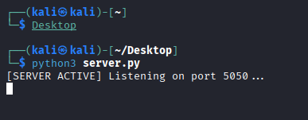

4. Finding Kali’s IP Address
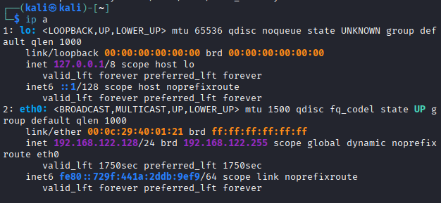

5. Setting Up the Client on Windows
5.1 Configuring the Client IP
In the client code, replace the server IP with Kali’s IP:
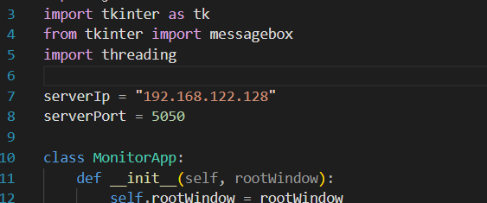
5.2 Running the Client
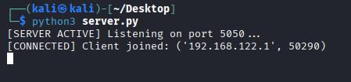
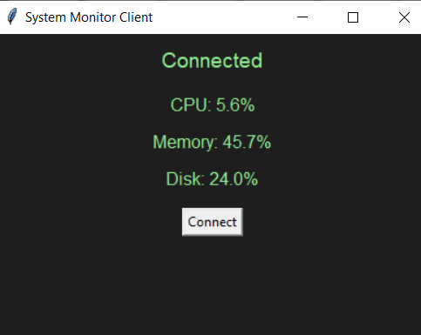
6. Socket Communication Flow
- Client sends a connection request
- Server accepts
- Server starts sending system stats
- Client displays the stats in GUI
- Connection closes upon exit

7. Networking Requirements
I must ensure the virtualization platform (VirtualBox / VMware) uses a mode that allows communication:
Recommended VM Network Modes
- Bridged Adapter (both machines appear on the same LAN)
- Host Only Adapter (direct PC ↔ VM communication)
Not recommended
- NAT only, Windows machine cannot reach the VM directly

8. Technologies Used
- Python
- Socket library
- psutil
- Tkinter
- JSON
- Threading

9. Cybersecurity Perspective
This mini lab demonstrates several real world cybersecurity concepts:
9.1 Remote Monitoring Agent
Kali server acts like a simplified version of:
- Elastic Beats agent
- CrowdStrike Falcon sensor
- OSQuery agent
- Wazuh agent
These tools collect telemetry and send it to a central dashboard exactly what my project does.
9.2 Secure Network Architecture
Separating the server (Kali) and client (Windows) simulates:
- Endpoint ↔ SOC server communication
- Segmented networks
- Remote health monitoring
- Agent server architecture used for detection & response (EDR)
9.3 Home Lab as a Real Use Case
This setup mirrors fundamental components of a cybersecurity environment:
Real World | My Lab
Monitored endpoint | Kali VM
Monitoring dashboard | Windows GUI client
Telemetry sent over network | Socket communication
CPU/Memory based anomaly detection | Threshold alerts
Agent based monitoring | server.py as monitoring agent
This demonstrates foundational knowledge used in incident response, system auditing, and threat detection.

10. Conclusion
I successfully built a functional monitoring system using socket programming, following a client server architecture across two isolated environments.
This home lab simulates real world cybersecurity tools and workflows, making it ideal for learning:
- Network communication
- Endpoint monitoring
- Agent based architecture
- Live system telemetry retrieval
- Cross platform connectivity
- Security environment design
This project is not only technically correct but also directly relevant to practical industry practices in cybersecurity and system administration.

